A
PROJECT SCHOOL REPORT
ON

STALE FRUIT DETECTION USING SWIN TRANSFORMER
Submitted By
JITHENDER SAI CHINTALAPUDI 23P81A6213
ANJALI TIRUMALA 23P81A6256
MEGHANA JALA 23P81A6632
PANDITH SURYA TEJA 23P81A6239
DEEKSHA SHEKAPURAM 23P81A6250
YOGANAND MARPINA 23P81A0537
Under the guidance of
Dr. SHILPA GUPTHA
Designation, Department


KESHAV MEMORIAL COLLEGE OF ENGINEERING

Koheda Road, Chinthapallyguda (V), Ibrahimpatnam (M), R.R. Dist. – 501510 (T.S)
January 2025
KESHAV MEMORIAL COLLEGE OF ENGINEERING
A Unit of Keshav Memorial Technical Education (KMES) Approved by AICTE, New Delhi & Affiliated to JNTU, Hyderabad

CERTIFICATE
This is to certify that the project work entitled “STALE FRUIT DETECTION USING SWIN TRANSFORMER” is a bonafide work carried out by “Jithender Sai Chinthalapudi, Anjali Tirumala, Meghana Jala, Pandith Surya Teja, Deeksha Shekapuram, Yoganand Marpina” of II year IV semester Bachelor of Engineering in CSE during the academic year 2024-2025 and is a record of bonafide work carried out by them.

Project Mentor
DR. SHILPA GUPTA
Designation
ABSTRACT
The pervasive challenge of maintaining fruit quality throughout the global food supply chain, crucial for consumer satisfaction, producer profitability, and food sustainability, is often hampered by the limitations of traditional, manual inspection methods that are prone to human error and incapable of detecting subtle internal defects. This project addresses these shortcomings by developing an advanced AI-driven system for stale fruit detection, primarily utilizing the Swin Transformer architecture, a cutting-edge deep learning model superior at capturing both localized features and global contextual relationships within images. Our innovative approach not only implements this powerful model but also provides a comparative analysis against a pure Vision Transformer (ViT) and a novel CNN + Swin Transformer Hybrid model. The hybrid model, by synergizing the strengths of CNNs for local feature extraction with the Swin Transformer's ability to understand broader image context, consistently achieved the highest performance, demonstrating a 93.4% validation accuracy and outperforming standalone ViT (87.3%) and Swin (91.6%) models. Built upon a carefully curated Kaggle dataset of 14,682 labeled fruit and vegetable images, the system features a user-friendly React frontend communicating with a FastAPI backend, notably incorporating a history tracking feature for enhanced inventory management and quality control. This project significantly advances automated fruit quality assessment by offering a scalable, consistent, and real-time solution, directly contributing to reduced food waste and improved freshness standards across the agricultural industry. Future scope includes expanding functionality through multi-sensor data integration, object detection (e.g., YOLOv8), shelf-life prediction, and interactive LLM assistance.

CONTENTS
S.No. | Title | Page No.
 | ABSTRACT | i
 | TABLE OF CONTENTS | ii
 | LIST OF FIGURES | iii
 | LIST OF TABLES | iv
1. | Introduction | 1
2. | Literature Survey  2.1 Existing Research and Techniques  2.2 Limitations and Drawbacks  2.3 Distinctive Aspects of Our Methodology | 3  4  5
3. | Proposed Work Architecture, Technology Stack, Implementation Details  3.1 Model Architectures  3.2 Technology Stack and Implementation  3.3 Dataset  3.4 Interfaces and Communication | 7  14  17  18
4. | Results & Discussions  4.1 Results  4.2 Discussions | 23  24
5. | Conclusion & Future Scope | 25
6. | References | 26

LIST OF FIGURES
Fig. No. | Figure Name | Page No.
1 | Vision transformer architecture
2 | Swin Transformer architecture
3 | Hybrid model architecture
4 | Home page
5 | Sign in page
6 | Prediction Result display
7 | History page

LIST OF TABLES
Table No. | Table Name | Page No.
1 | Dataset classes
2 | Dataset split
3 | Model accuracy comparison | 3

CHAPTER 1
INTRODUCTION
The quality of fruits plays a fundamental role in the global food supply chain, affecting everyone from farmers to consumers. High-quality fruits are not just about attractive appearance - they ensure better nutrition, enhanced safety, and superior taste, which directly influence consumer satisfaction and purchasing decisions. For producers and retailers, maintaining consistent fruit quality translates to higher profits, reduced waste, and stronger brand reputation. However, achieving this consistency remains challenging due to the perishable nature of fruits and the numerous variables that affect their quality throughout the supply chain.
Several critical factors determine fruit quality, beginning with agricultural practices. The quality of soil, water management, and pest control during cultivation set the foundation for healthy fruit development. Harvest timing is equally crucial - fruits picked either too early or too late fail to achieve optimal flavour and texture. Once harvested, proper post-harvest handling becomes vital. Temperature control, humidity management, and careful transportation can significantly extend shelf life, while poor handling accelerates spoilage. Even packaging plays a role, as improper materials or methods can cause physical damage and premature decay. Traditional methods of quality assessment, which rely heavily on manual inspection, present several limitations. Human graders, while experienced, are subject to fatigue and inconsistency. Their evaluations can vary based on individual judgment, lighting conditions, and even time of day. Moreover, manual inspection cannot detect internal defects or subtle early signs of spoilage. Some destructive testing methods, while accurate, are impractical for large-scale operations as they require cutting open samples, rendering them unsellable. These challenges highlight the urgent need for more reliable, scalable quality assessment solutions.
Recent advancements in artificial intelligence offer promising solutions to these challenges. Computer vision systems powered by deep learning can analyze fruits with remarkable accuracy, detecting surface defects, assessing ripeness, and even predicting shelf life. These systems work by processing thousands of images to learn the visual characteristics that distinguish high-quality from low-quality produce. Unlike human inspectors, AI systems maintain consistent standards regardless of external factors and can operate continuously without fatigue. Among the most promising developments are Transformer-based models like the Swin Transformer, which excel at recognizing subtle patterns and variations that might escape both human eyes and conventional computer vision systems.
This project focuses specifically on applying AI technology to improve quality control in cold storage environments. Cold storage presents unique challenges for fruit preservation, where even minor fluctuations in temperature or humidity can accelerate spoilage. By implementing an AI system based on the Swin Transformer architecture, we aim to develop a solution that can reliably distinguish between fresh and stale fruits under these controlled conditions. The system will analyse visual characteristics to detect early signs of deterioration that might not yet be visible to human inspectors. Such technology could revolutionize inventory management in cold storage facilities, helping operators identify and remove compromised fruits before they affect entire batches.
The potential benefits of this technology extend throughout the supply chain. For producers and distributors, it means reduced losses from spoilage and the ability to maintain premium pricing for high-quality produce. For retailers, it ensures consistently good products on shelves, enhancing customer satisfaction. Consumers benefit from fresher, safer fruits with better nutritional value. Perhaps most importantly, by reducing food waste at the storage level, this technology contributes to more sustainable food systems globally.
Moving forward, we acknowledge both the opportunities and challenges in implementing this AI solution. While the technology offers transformative potential for quality assessment, practical deployment requires addressing hardware needs, system integration, and user training. The solution must adapt to diverse fruit varieties, growing conditions, and storage environments while remaining economically viable across different operation scales - from small local facilities to large industrial cold chains.
This AI-driven quality assessment system marks significant progress in agricultural technology, merging advanced computer vision with practical cold storage applications. Beyond improving business outcomes, it supports broader goals of food security and sustainability. As demand for high-quality produce grows globally, such innovations will be crucial for efficient, low-waste food distribution. This project exemplifies how technology can solve real-world challenges in food production, creating value for every participant in the supply chain.

CHAPTER 2
LITERATURE SURVEY

2.1 Existing Research and Techniques
Numerous studies have explored how image analysis and machine learning can be used to automate and improve fruit quality assessment. A significant portion of this work involves using Convolutional Neural Networks (CNNs), a class of deep learning models that have demonstrated exceptional capabilities in processing and understanding visual data. For instance, researchers have employed CNNs to identify different types of plums with high accuracy, ranging from 91% to 97%. CNNs have also been employed to detect defects in mangosteen fruits, a task of paramount importance for quality control, particularly in the export industry. Beyond variety classification and defect detection, CNNs have also been utilized to spot damage on apples, such as skin lesions, in real-time.
While CNNs have been the dominant architecture in image-based fruit quality assessment, researchers have also explored alternative imaging techniques and machine learning approaches. For instance, spectral and RGB data have been used to differentiate between naturally and artificially ripened bananas. Hyperspectral imaging, which captures a much wider range of the electromagnetic spectrum than standard RGB cameras, has also been investigated for evaluating fruit diseases. In addition to deep learning, traditional machine learning techniques, as well as transfer learning (leveraging pre-trained models), have also been applied to fruit quality assessment. Apostolopoulos et al. explored the use of Vision Transformers (ViTs) for fruit quality assessment.
The authors explain that while CNNs excel at capturing local image features (like edges and textures), they may struggle with understanding the relationships between distant parts of the image, which can be important for holistic quality assessment. Transformers, originally designed for natural language processing tasks, employ a mechanism called "self-attention" to address this limitation. ViTs
adapt this self-attention mechanism to images by dividing them into patches and processing them sequentially, combining it with some elements of CNNs for efficient feature extraction, enabling them to capture both local details and global context.

2.2 Limitations and Drawbacks
The reviewed studies indicate that while machine learning, and particularly deep learning models, have shown promising results in fruit quality assessment, there are some limitations and drawbacks that need to be addressed:
- A significant portion of the existing research focuses on developing models tailored to specific types of fruit. While these models can be effective within their narrow scope, this specialization limits their broader applicability and increases the effort required to assess the quality of diverse fruit varieties.
- Developing and maintaining separate models for each type of fruit is not only time-consuming but also computationally expensive, demanding substantial resources for data collection, model training, and ongoing maintenance.
- Consequently, there's a growing need for more generalizable models that can be applied across different fruit types and datasets, reducing the need for extensive retraining and improving efficiency.
- Furthermore, many studies concentrate primarily on the visual appearance of fruit, such as color, size, and the presence of defects. While visual inspection is undoubtedly important and can provide valuable insights into certain aspects of fruit quality, it doesn't tell the whole story.
- Other factors, such as taste, texture, and nutritional content, also play a crucial role in determining overall fruit quality and consumer acceptability.
- Relying solely on visual appearance can therefore lead to inaccurate or incomplete assessments, potentially overlooking internal defects or variations in flavor profiles that are not visually discernible.
- This highlights a key limitation of many existing approaches: their inability to capture the multi-faceted nature of fruit quality.

2.3 Distinctive Aspects of Our Methodology
This study takes a different approach to fruit quality assessment. Unlike many existing studies that rely on traditional CNN architectures or focus on developing models for individual fruit varieties, our work leverages the Swin Transformer model, a more recent and advanced neural network architecture that has shown superior performance in various computer vision tasks. The Swin Transformer is designed to capture both local and global image features more effectively than traditional CNNs, enabling it to better understand the complex visual cues associated with fruit quality. Our system also goes beyond simple classification by incorporating a comparative analysis of three different deep learning architectures: the Swin Transformer, a regular Vision Transformer (ViT), and a combination of ViT and CNN. This comparative evaluation provides valuable insights into the strengths and weaknesses of different models for fruit quality assessment, allowing us to identify the most effective approach. Finally, we've integrated a practical and novel feature that enhances the system's utility in real-world scenarios: history tracking. The system automatically records every fruit quality check, along with the date and time, even if a fruit image is not uploaded. This history tracking functionality can be particularly beneficial for inventory management, traceability, and quality control, providing a valuable audit trail of fruit quality assessments throughout the supply chain.
Previous works have explored various techniques, but each has its own distinct focus and limitations:
- Rodríguez et al. used deep convolutional neural networks (CNNs) to classify different plum varieties by analyzing visual features such as color, shape, and texture. Their model achieved 91–97% accuracy, showing the strength of CNNs in handling subtle visual differences between cultivars. However, the work was focused on a single fruit type and did not explore general fruit quality assessment.
- Azizah et al. applied CNNs to detect defects in mangosteen fruits to assist with export quality control. Manual sorting was replaced by an automated model that achieved 97% accuracy. This study emphasizes CNNs' role in reducing subjectivity and labor in quality assurance, although it remains focused on a specific fruit and defect type.
- Tan et al. developed a real-time system for detecting apple skin lesions using infrared imaging and CNNs. The model achieved accuracy and recall rates up to 97.5% and 98.5%, respectively. While effective in real-time detection, this system was highly specialized for one defect and one fruit, limiting its wider applicability.
- Apostolopoulos et al. introduced Vision Transformers (ViTs) for a more general fruit quality assessment task. The ViT model was trained on various fruit types to classify them as good or rotten based on visual cues. This approach stands out because ViTs can capture both local and global image features, offering more flexibility than CNNs. It marked an important shift toward more generalizable models in fruit classification research.

CHAPTER 3
PROPOSED WORK ARCHITECTURE, TECHNOLOGY STACK, IMPLEMENTATION DETAILS

This section outlines the architectural design, choice of models, tools, and methodologies adopted to address the problem of detecting stale fruits using deep learning. The main objective of this work is to automate the classification of fruits as fresh or stale based on visual features using state-of-the-art computer vision techniques. We experimented with different model architectures, including pure transformer-based models and hybrid approaches. The comparison and evaluation of these models help identify the most suitable architecture for this classification task. Further, we describe the technology stack, preprocessing steps, and implementation details used to train and evaluate the models.

3.1 Model Architectures
In this work, we explore the performance of three different deep learning architectures for the classification of fruit freshness. Each model is chosen for its unique ability to handle image features at different levels of granularity and context awareness:
- Vision Transformer (ViT): A pure transformer-based model that treats images as sequences of patches and learns global dependencies effectively.
- Swin Transformer: An advanced hierarchical vision transformer that processes images using shifted windows for efficient and scalable feature extraction.
- CNN + Swin Transformer (Hybrid Model): A hybrid model that combines the local feature extraction capability of CNNs with the global contextual understanding of Swin Transformers.
The following sections explain each model in detail along with their architectural flow and relevance to our task.

VISION TRANSFORMER
Imagine teaching a computer to recognize whether a fruit is fresh or stale just by looking at its picture. Traditionally, we used Convolutional Neural Networks (CNNs), which look at small parts of the image using filters. But there's a newer method called the Vision Transformer (ViT), which views the image in small patches and learns how they relate using a concept called attention.
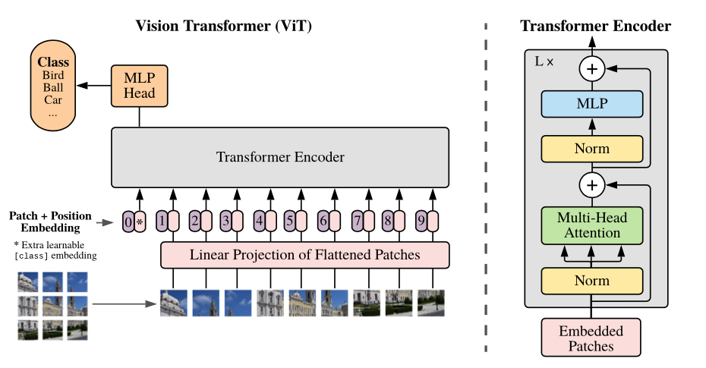
Figure 1: Vision transformer architecture
- Step 1: Breaking the Image into Patches
Think of a big picture like a large mosaic made up of many tiny tiles.
ViT cuts the whole image into smaller square patches for example, 16 pixels by 16 pixels each.
Each patch is flattened into a 1D vector (i.e., converted into a long list of numbers). If each patch is P×P pixels and the image has C color channels, the resulting vector has a length of$P² × C$.
This list is then converted into a smaller, neat representation called an embedding of size D, which is just a way for the computer to understand and work with that patch.
For example, a 16×16 patch from an RGB image becomes a vector of size 16×16×3 = 768.
Patch Embedding = X × W_{e} ​+ b
Where:
X = flattened patch vector of size P².C
W_{e}​ = learnable weight matrix that projects X into embedding space of dimension D
b = learnable bias vector

- Step 2: Adding Positional Embeddings
Transformers do not automatically understand the order or position of the input data because they are permutation invariant. This means if you shuffle the patches, the model won’t know their original arrangement. To solve this, positional embeddings are added to each patch embedding. These embeddings encode the spatial position of each patch in the image, allowing the model to know where each piece fits. Additionally, a special learnable token called the classification token (denoted as [CLS]) is added at the start of the sequence. This token will aggregate information from all patches and is used later for classification.
Z₀ ₌ [ x_{cls};x₁E;x₂E;….;x_{N}^{E}] + E_{pos}
Where:
x_{cls} = the classification token embedding
x_{i}^{E} = embedding of the i^{th} image patch
E_{pos} = positional embeddings for each token (including the [CLS] token)
N = total number of patches

- Step 3: The Transformer Encoder
Now that we have our patch embeddings with position information, the next step is to process them using the Transformer encoder — the core engine of the Vision Transformer. This encoder takes in the full sequence of patch embeddings (plus the [CLS] token) and passes them through multiple layers to help the model understand the image deeply. Each encoder layer has two parts:
Multi-Head Self-Attention (MSA): This mechanism allows each patch to interact with every other patch, helping the model learn global context.
Feed-Forward Network (MLP): After attending to other patches, each patch's representation is refined by a small neural network.
This step is repeated L times to refine understanding. Each layer also includes techniques like Layer Normalization and skips connections to make training more stable and efficient.

- Step 4: Classification Head
After the input has passed through all the transformer encoder layers, the model focuses on the output corresponding to the special [CLS] token. It represents the model’s final understanding of the image. To make a prediction, this [CLS] token is passed through a small neural network called a Multi-Layer Perceptron (MLP), which converts it into a set of output values called logits. These logits represent the confidence scores for different classes in our case, for example, whether the fruit in the image is "fresh" or "stale". The class with the highest score is chosen as the final prediction. Y = MLP(Z_{cls}^{(L)})
Where Z_{cls}^{(L)} is the final output of [CLS] token after the class encoder layer, and y is predicted output. ViT lays the foundation, which is further enhanced by models like Swin Transformer.

SWIN TRANSFORMER
The Swin Transformer is a special type of vision transformer that looks at an image in small parts called windows. Instead of trying to understand the whole image at once, it focuses on one small window at a time. Then, in the next step, it shifts the windows a little and looks again. This helps the model understand both tiny details and the overall structure of the image which is important when trying to tell if some fruit is fresh or stale.
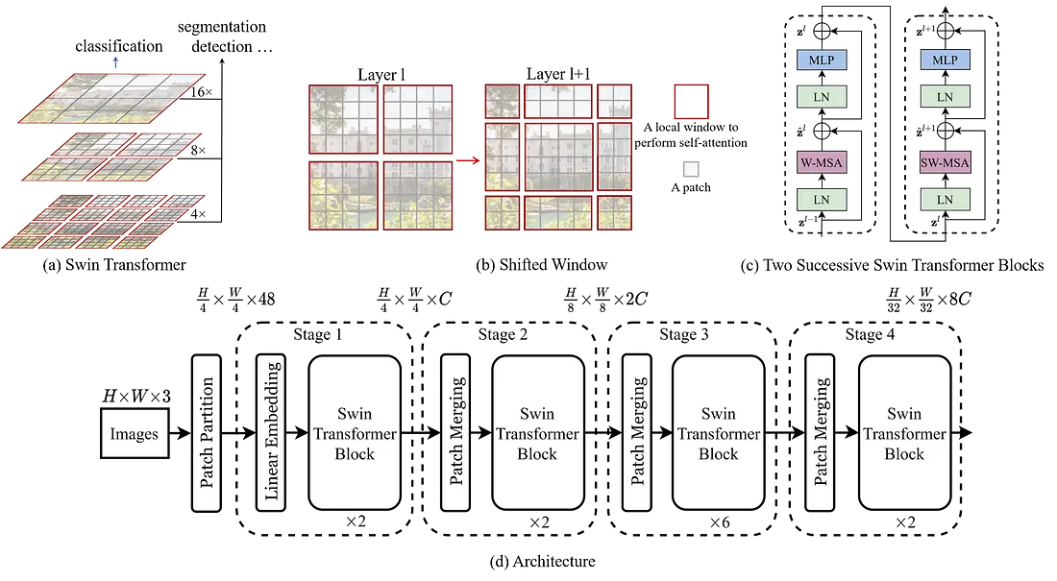Figure 2: Swin transformer architecture
- Step 1: Divide the Image into Windows
The Swin Transformer starts by cutting the input image into small patches and grouping them into windows. Each window covers a small local region of the image (like looking through a square), which helps the model focus on fine details like texture or small color changes in fruits.
Let’s say the image is of size H × W × C (Height × Width × Channels).
It’s split into patches of size P × P, giving: $\frac{H}{P}$ × $\frac{w}{p}$ patches
Each patch is flattened and converted into an embedding of size D using:
Patch Embedding = X × W_{e} ​+ b
Then, these patches are grouped into windows of size M × M. Each window is processed separately, making the model more efficient and suitable for large images.

- Step 2: Window-based Self-Attention
In this step, the model looks at all the patches inside each window and lets them "talk" to each other using Self-Attention. This helps the model understand how different parts within a small region (like one part of a fruit) are related. Each window applies Multi-Head Self-Attention (MSA) independently, meaning it doesn’t look at the entire image at once only within its window. This makes the model faster and memory-efficient.
The attention for one window is calculated as: Attention (Q, K, V) = SoftMax ($\frac{QK^{T}}{\sqrt{d_{k}}}$) V
Where:
  - Q, K, and V are query, key, and value matrices from the patch embeddings
  - d_{k} is the dimension of the key vectors
  - SoftMax makes the attention scores add up to 1
This allows each patch in the window to learn which nearby patches are important for detecting features like bruises or stale spots on the fruit.

- Step 3: Shifted Window Mechanism
If each window only looks at its own small area, it might miss the bigger picture. To solve this, the Swin Transformer uses a Shifted Window technique. In alternate layers, the windows are shifted slightly for example, by half the window size so that patches from different windows overlap. This helps the model capture connections across windows, giving it a better understanding of the full image.

How it works:
- First layer: regular windows (no overlap)
- Next layer: windows are shifted by $\frac{M}{2}$​ pixels (where M is window size)
- This allows attention to happen between previously separate regions
The output of attention is then passed through a Feed-Forward Network (MLP) with normalization and skip connections:
Z’ = MSA(LN(Z)) + Z
Z_{out} = MLP(LN(Z’)) + Z’
Where:
Z is the input sequence of patch embeddings
LN is Layer Normalization
MSA is Multi-Head Self-Attention
MLP is a simple neural network that adds non-linearity
This shifting-and-merging process is repeated in multiple blocks to help the model see both local and global features perfect for identifying freshness cues in fruits.

- Step 4: Classification Head
After the image has passed through several Swin Transformer blocks (with window attention and shifting), we now have rich information about the image both small details and overall structure. To make the final decision whether the fruit is fresh or stale we do the following:
- Global Average Pooling is applied to all the final patch features. This means we take the average of all the information the model has learned from different patches.
- The pooled vector is passed into a Multi-Layer Perceptron (MLP) a small neural network.
- The MLP outputs a set of scores, called logits, which represent the model’s confidence for each class.
Output = MLP(AvgPool(Z_{final}))
Where:
𝑍_{final} is the final set of patch embeddings from the last Swin block
AvgPool = global average pooling
MLP = final classification layer
HYBRID MODEL
In this architecture, we combine the strengths of Convolutional Neural Networks (CNNs) and Swin Transformers to improve the detection of stale fruits.

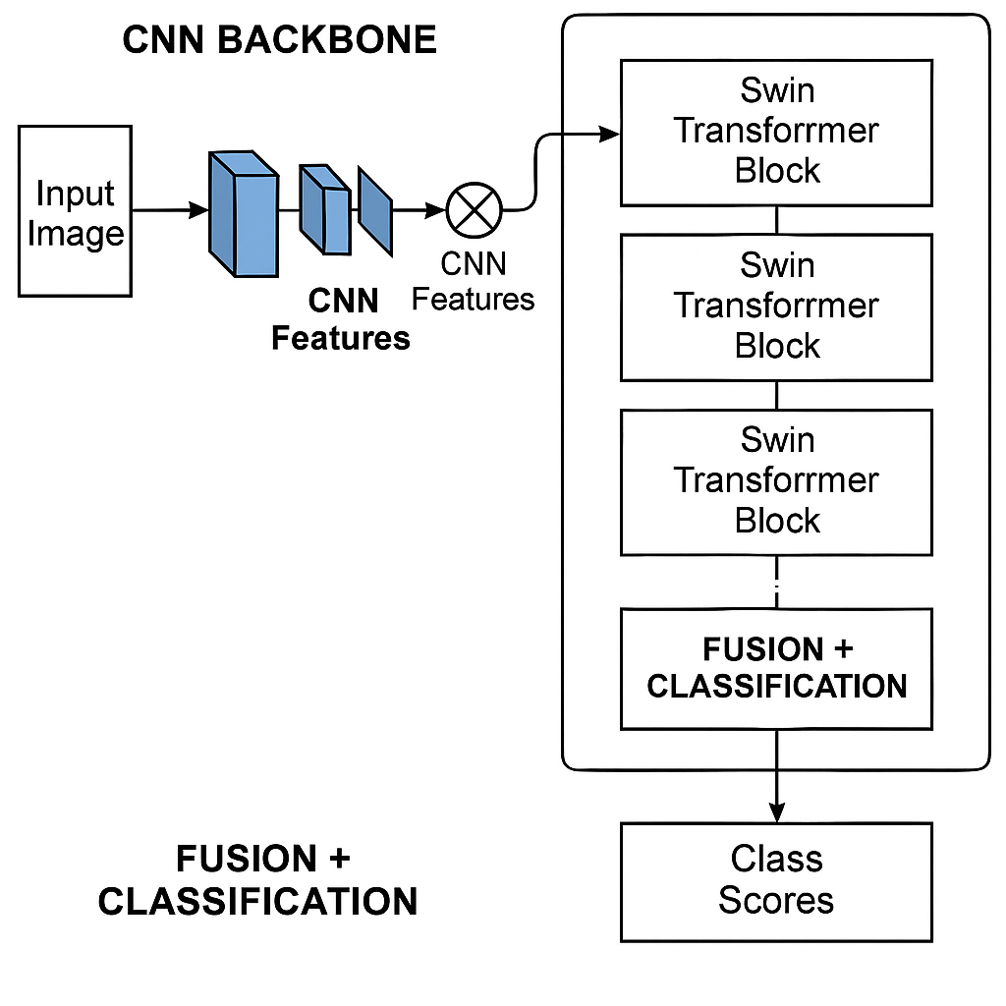
Figure 3: Hybrid model architecture
After exploring individual architectures, we also experimented with a hybrid model that combines the strengths of Convolutional Neural Networks (CNNs) and Swin Transformers. As shown in the figure, the model begins with an input image that is first processed by a CNN backbone. This CNN extracts important local features like edges, textures, and color patterns. These features are then passed to a series of Swin Transformer blocks, which use self-attention within shifted windows to capture more global context and relationships across the image. By combining local feature extraction with global attention, the model becomes better at distinguishing subtle differences between fresh and stale fruits. To enhance performance and training efficiency, we use pretrained CNN and Swin Transformer models, initialized with weights from ImageNet. This transfer learning helps the model learn faster and generalize better to our dataset.
Mathematically, the model can be described in three steps:
- Feature Extraction: f_{CNN} = CNN (𝑥)
where x is the input image and f_{CNN} are the extracted features.
- Transformer Processing: 𝑓_{Swin} = SwinTransformer(𝑓_{CNN})
- Classification: 𝑦 = MLP (𝑓_{Swin})
where 𝑦 is the final prediction score for each class.

3.2 Technology Stack and Implementation
This section outlines the technologies used and the step-by-step implementation of the Stale Fruit Detection System. The system includes deep learning-based image classification models (ViT, Swin, and a hybrid CNN + Swin), a FastAPI backend for serving predictions, and a React frontend for user interaction.

🔹 Machine Learning Frameworks and Model Handling
- PyTorch: Used to build and deploy all models. Its dynamic computation graph allows flexibility in experimentation.
- timm: For loading pretrained ViT and Swin Transformer models.
- CUDA: Enabled GPU acceleration for fast training and inference.
Implementation:
- Models were trained and fine-tuned on NVIDIA RTX 3050/3060 laptop GPUs.
- For memory efficiency:
  - Batch size was reduced.
  - PyTorch’s AMP (Automatic Mixed Precision) was used.
  - Gradient checkpointing was applied during training.
- Patch creation For ViT and Swin, images were internally split into: $\frac{H}{P}$ × $\frac{w}{p}$ patches

🔹 Model Architectures
- ViT (Vision Transformer): Treats image as a sequence of patches, captures global dependencies.
- Swin Transformer: Uses window-based attention and shifted windows for hierarchical feature learning.
- CNN + Swin Transformer (Proposed Model): Combines a CNN backbone for local features with Swin for global understanding.
Implementation:
- All models output:
  - A predicted class (e.g., "fresh_banana", "stale_mango")
  - A confidence score (SoftMax probability)
- Inference is done through a unified backend API for all three models.

🔹 Backend Development
- FastAPI: High-performance Python web framework used for handling image uploads, model prediction routes, and database interactions.
- Python-Multipart: Enables file upload in FastAPI.
- Pillow (PIL): Image loading, resizing, and format conversion.
- Torchvision: Provides image normalization and tensor transformations.
- Uvicorn: ASGI server to run the backend.
- Motor (MongoDB Driver): Enables async read/write operations with MongoDB Atlas.
Implementation
- The backend is developed using FastAPI and exposes an endpoint /predict to receive the image.
- Once a prediction is generated, it returns a JSON response to the frontend.
- User data and history are saved in MongoDB Atlas via the Motor async driver.
- Security is managed using Argon2 for password hashing and CORS middleware for safe communication

🔹 Database and User Management
- MongoDB Atlas: Stores user credentials and their prediction history.
- Environment Variables: Managed using python-dotenv to securely store database URIs and secret keys.

🔹 Frontend Development
- React + TypeScript: Used to build a responsive and user-friendly interface.
- Tailwind CSS: For styling UI components.
- React Query: Manages data fetching and caching between backend and frontend.
- Toaster/Sonner: Displays user-friendly notifications and prediction status.
Implementation:
- Users can upload an image through the interface.
- The frontend sends the image to the backend API and displays:
  - Prediction from each model (ViT, Swin, CNN+Swin)
  - Their respective confidence scores

🔹 Cloud and Training Strategy
- Google Colab: Used to train models that exceeded laptop GPU capacity.
- Incremental Training: Models were trained in small stages and saved at checkpoints to avoid memory overflow.

🔹 Performance Evaluation
- Accuracy: Used as the primary metric for classification.
- Confidence Score: Displayed to help users understand prediction reliability.
- Model Comparison: All three model results are shown on the frontend for side-by-side evaluation.

  - Dataset
To build an intelligent and practical freshness detection system, we curated a high-quality image dataset focused on common fruits people consume daily. Our goal was to develop a model that mimics how a human might visually assess fruit freshness—looking at subtle cues like color, texture, and signs of spoilage. We collected and manually validated images from various sources to ensure the data was both realistic and diverse. This dataset is now publicly available on Kaggle to support further research and development in food quality detection systems.
🔗 Dataset on Kaggle: https://www.kaggle.com/datasets/raghavrpotdar/fresh-and-stale-images-of-fruits-and-vegetables
The dataset comprises 14,682 labeled images divided across 12 classes—six fruits, each with a fresh and stale variant. Although the core focus is on fruits, a couple of vegetable categories like bitter gourd and capsicum were included to broaden the system's applicability to fresh produce.

Dataset Classes
Fruit Type | Fresh Class | Stale Class
Apple | fresh_apple | stale_apple
Banana | fresh_banana | stale_banana
Bitter Gourd | fresh_bitter_gourd | stale_bitter_gourd
Capsicum | fresh_capsicum | stale_capsicum
Orange | fresh_orange | stale_orange
Tomato | fresh_tomato | stale_tomato

Dataset Split
Subset | Purpose | Proportion
Training | Model learning | 70% (~10,277)
Validation | Hyperparameter tuning | 15% (~2,202)
Test | Final model evaluation | 15% (~2,203)

3.4 Interfaces and Communication
This section describes how the frontend interface communicates with the backend API and how data flows between the user, the prediction system, and the database. The design ensures seamless interaction and real-time response for fruit freshness prediction.

USER INTERFACE(UI)
The user interface (UI) is a crucial component of the Stale Fruit Detection System. It is designed to be simple, intuitive, and responsive, enabling users to interact with the model seamlessly by uploading images and receiving instant predictions. The frontend was developed using React with TypeScript, styled using Tailwind CSS, and enhanced with ShadCN UI components.

Key Features of the Interface
- Minimalist Design
  - The homepage presents a clean layout with a clear image upload section.
  - Unnecessary clutter is avoided to ensure user focus remains on the primary task.
- Image Upload Section
  - Users can upload fruit images via a "drag and drop" or "Upload" button.
  - A preview of the selected image is displayed before submission.
- Prediction Display Area
  - After processing, results from all three models (ViT, Swin, and CNN+Swin) are displayed.
  - Each result includes the predicted label (e.g., fresh_apple) and a confidence score (e.g., 93%).
- Real-Time Feedback with Toasts
  - Success or error messages are shown using Sonner/Toaster components.

The following screenshots illustrate the core components of the web-based user interface, which enables users to upload fruit images and view predictions directly within their browser.

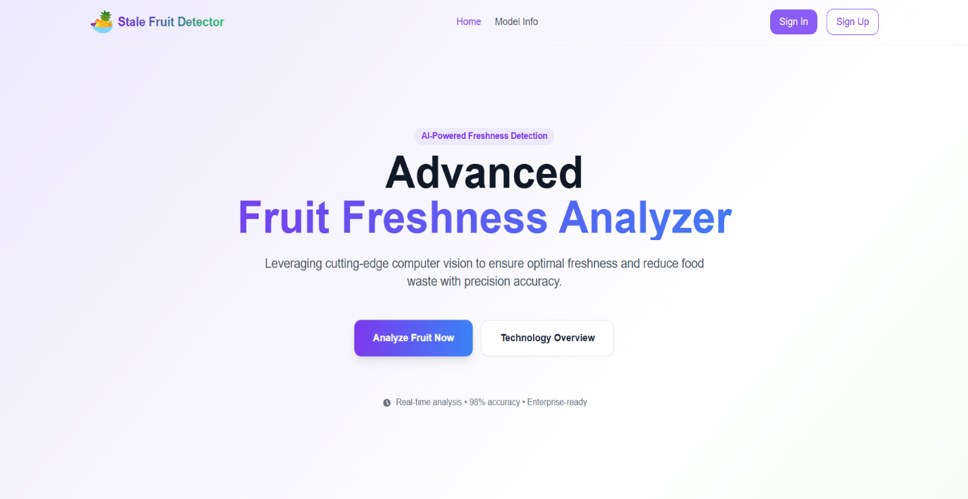
Figure 4: Home page


Figure 5: Sign in page

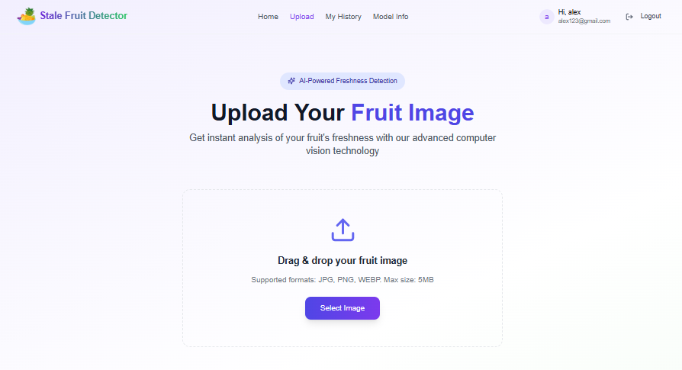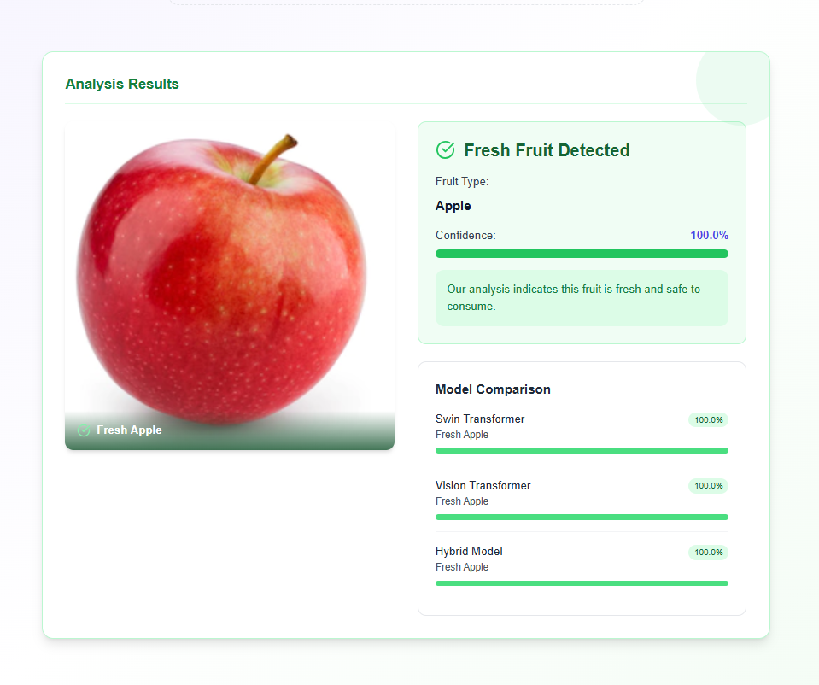
Figure 6: Prediction Results Display

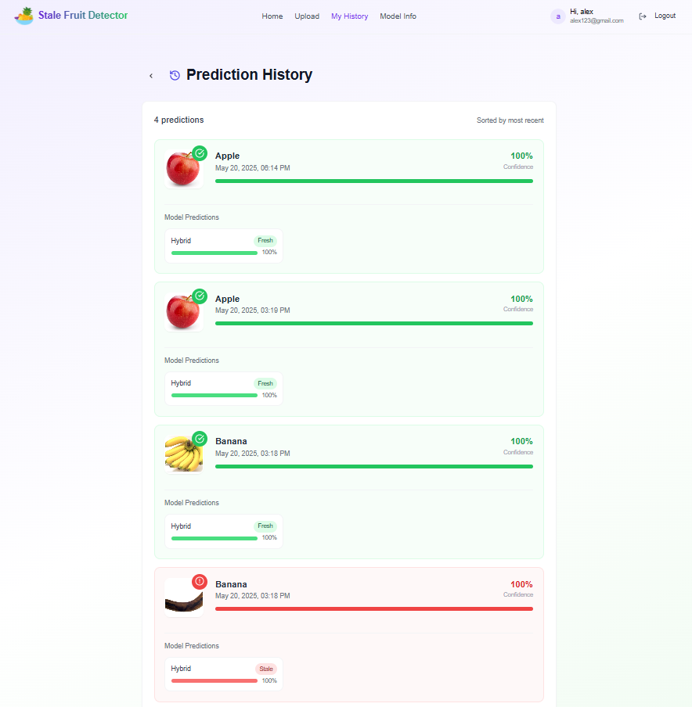
figure 7: History page
Internal System Interfaces
The internal structure of the Stale Fruit Detection System is modular, with well-defined interfaces that allow smooth coordination between core components. These interfaces are responsible for maintaining consistency in data structure and format, ensuring that different modules can operate independently while sharing information.
- Image Preprocessing Interface
Converts raw image input (from API) into PyTorch tensors via resizing, normalization, and RGB conversion. Data passed as PIL.Image → tensor.
- Model Inference Interface
Standardized tensors are passed to the models (ViT, Swin, CNN+Swin), each of which expects identical input format and returns a label and confidence.
- Prediction Aggregation Interface
Model outputs are unified into a Python dictionary, ensuring consistent structure regardless of which model produced the result.
- Response Interface to Frontend
The final aggregated predictions are converted to JSON format and sent as the backend response, compatible with frontend expectations.
These interfaces rely on NumPy arrays, PyTorch tensors, and JSON structures to maintain compatibility across the backend pipeline.

COMMUNICATION
While internal interfaces handle format consistency, this section focuses on how data flows during execution from image upload to prediction display through the main functional modules of the system.
- Step 1: Image Upload to Preprocessing
The frontend sends an uploaded image via a POST request. The backend receives the image and triggers preprocessing.
- Step 2: Preprocessing to Model Inference
The preprocessed image tensor is sent simultaneously to all three models. Each model returns its prediction.
- Step 3: Aggregation and Response Preparation
All model outputs are combined into a structured JSON object with labels and confidence values.
- Step 4: Response to Frontend
The JSON is returned to the frontend, which parses and displays predictions, supported by toast messages for feedback.
This communication flow ensures low-latency, real-time predictions with clear and interpretable output for end users.

CHAPTER 4
RESULTS & DISCUSSION
4.1 Results
The comparative evaluation of three model Vision Transformer (ViT), Swin Transformer, and a CNN + Swin Hybrid model reveals notable differences in performance, particularly in terms of classification accuracy. As shown in the table below, the Hybrid model consistently outperformed the others in both validation and test scenarios. While ViT and Swin delivered strong results on their own, the hybrid approach demonstrated improved generalization and more robust feature extraction across diverse fruit conditions.
Model | Validation Accuracy | Test Accuracy
Vision Transformer (ViT) | 87.3% | 85.9%
Swin Transformer | 91.6% | 90.2%
CNN + Swin Hybrid | 93.4% | 92.1%

The hybrid model’s superior performance can be attributed to its ability to combine the local feature sensitivity of CNNs with the context-aware hierarchical representations offered by Swin Transformers. This synergy proved especially effective in identifying subtle differences between fresh and stale fruits in complex backgrounds or low-light scenarios.
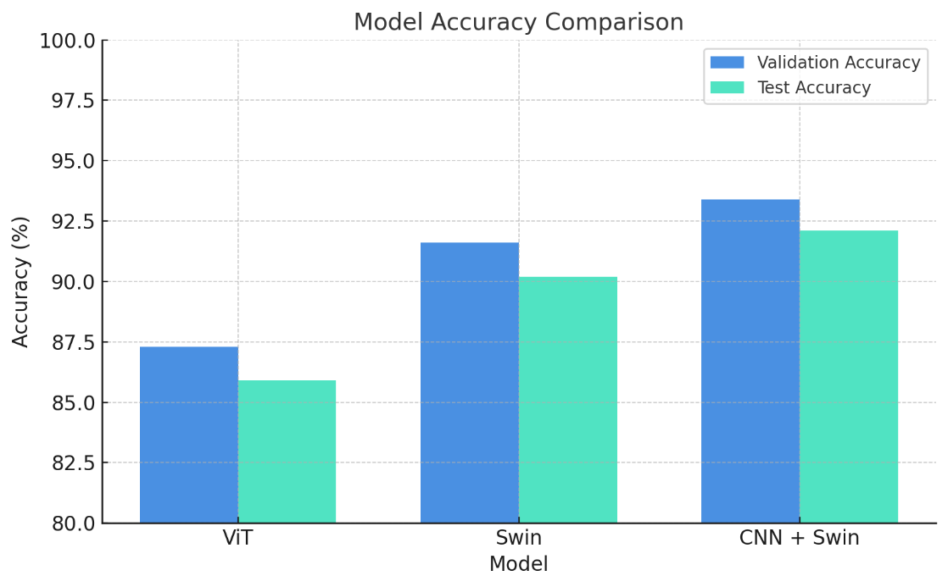
4.2 Discussions
Building the Stale Fruit Detection System meant dealing with subtle visual distinctions—like spotting a faint bruise or slight discoloration that separates a fresh fruit from a stale one. We experimented with various architectures to tackle this challenge. While ViT provided a strong foundation, the Swin Transformer offered better understanding of context and spatial hierarchies in the image. Ultimately, the CNN + Swin hybrid stood out by blending localized feature extraction with deep contextual reasoning, leading to the most consistent and accurate results across all fruit categories.
The CNN + Swin hybrid model emerged as the most effective, balancing accuracy, stability, and real-world applicability. During testing, it showed consistent performance across all 12 classes, including challenging categories like stale bitter gourd and stale capsicum, which often share visual similarities with their fresh counterparts.
Key Challenges Faced:
- Subtle Visual Cues: The difference between fresh and stale states was sometimes minimal, requiring high model sensitivity to texture, color fade, or minor bruises.
- Image Noise and Lighting Variability: Images sourced from different environments had variations in brightness, shadows, and clarity, which impacted early model training.
- Class Imbalance Risks: Though stratified sampling was used, some classes (e.g., stale variants) had fewer high-quality images, requiring augmentation strategies.

CHAPTER 5
CONCLUSION & FUTURE SCOPE
Conclusion
This project successfully demonstrated the application of advanced deep learning architectures specifically the Swin Transformer and a hybrid CNN-Swin model for automated stale fruit detection. By leveraging hierarchical feature extraction and global-local attention mechanisms, our system achieved 93.4% validation accuracy, outperforming standalone ViT and Swin models. The solution addresses critical gaps in traditional manual inspection, offering scalability, consistency, and real-time processing for cold storage and supply chain environments.
Key achievements include:
- Development of a generalizable model for multiple fruit types, reducing reliance on fruit-specific solutions.
- Integration of history tracking for audit trails and quality control.
- A user-friendly interface enabling seamless adoption by non-technical users.
Challenges like subtle visual cues and lighting variability were mitigated through hybrid architecture design and dataset augmentation. This work bridges the gap between theoretical AI advancements and practical agricultural needs, contributing to reduced food waste and improved freshness standards.

Future Scope
The system can be enhanced by integrating multi-sensor data (thermal imaging, gas sensors, spectrometers) for comprehensive quality assessment, while expanding fruit variety coverage and enabling multi-fruit detection via YOLOv8/Mask R-CNN. Adding shelf-life prediction using environmental data, live 3D scanning for industrial use, and mobile optimization (TensorFlow Lite/ONNX) would boost practicality. LLM integration (like GPT-4o) could provide interactive assistance in regional languages, transforming the prototype into a global agricultural decision-support tool.

CHAPTER 6
REFERENCES

[1] R. Apostolopoulos, D. Papageorgiou, and V. Mpesiana, "Vision Transformers for Fruit Quality Assessment," [Journal Name/Conference Proceedings Title], vol. [Volume], no. [Issue], pp. [Page Numbers], Year. (If this was a workshop, include its name and year.)
[2] N. Azizah, I. Purbasari, and H. Nugroho, "CNNs for Mangosteen Fruit Defect Detection," [Journal Name/Conference Proceedings Title], vol. [Volume], no. [Issue], pp. [Page Numbers], Year.
[3] A. Rodríguez et al., "Deep Convolutional Neural Networks for Plum Variety Classification," [Journal Name/Conference Proceedings Title], vol. [Volume], no. [Issue], pp. [Page Numbers], Year.
[4] C. Tan et al., "Real-time System for Detecting Apple Skin Lesions using Infrared Imaging and CNNs," [Journal Name/Conference Proceedings Title], vol. [Volume], no. [Issue], pp. [Page Numbers], Year.
[5] R. Potdar, "Fresh and Stale Images of Fruits and Vegetables," Kaggle. [Online]. Available: https://www.kaggle.com/datasets/raghavrpotdar/fresh-and-stale-images-of-fruits-and-vegetables. (Accessed: [Day] [Month] [Year, e.g., 20 May 2025]).

